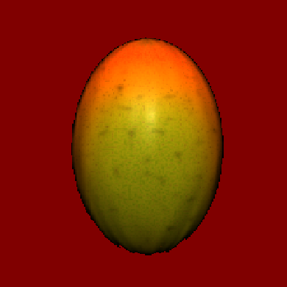
Café Mango
Takeaway menu

Sandwiches Baguettes/ciabatta Just salad (V) £2.10 £2.30
Mature cheddar cheese & pickle (V) £2.20 £2.40
Mature cheddar cheese mayo & onion (V) £2.20 £2.40
Tuna mayonnaise £2.10 £2.30
Free range egg mayo & bacon £2.40 £2.60
Free range egg mayonnaise (V) £2.25 £2.35
Bacon, lettuce & tomato £2.40 £2.60
Cream cheese, bacon & tomato £2.40 £2.60
Sausage £2.40 £2.60
Bacon £2.50 £2.80
Baked ham & tomato £2.35 £2.55
Roast turkey mayo salad £2.40 £2.60
Roast turkey & Cranberry sauce £2.40 £2.60
Roast beef and horseradish sauce £2.85 £3.00
Coronation chicken £2.85 £3.05
Sun dried tomato, mozzarella, basil & olives (V) £2.50 £2.70
Feta, olives & tomato (V) £2.50 £2.70
Brie & tomato (V) £2.40 £2.60
Brie & cranberry (V) £2.40 £2.60
Bacon & mature cheddar or brie £2.60 £2.80
Chicken mayonnaise £2.70 £2.90
Chicken mayo, lettuce & Bacon £2.85 £3.05
Cream cheese & prawns £2.75 £2.95
Prawns in seafood sauce £2.70 £2.90
Prawn & avocado £2.85 £3.00
Cream cheese & red peppers and walnuts (V) £2.20 £2.40

The above are available on thick cut sandwiches, baguettes or ciabatta, white or granary. All of our products are freshly prepared. Our baguettes and Ciabatta are all freshly baked on the premises.
[Add 10p for salad.]

Panini’s
Tuna, tarragon & mozzarella £3.00
Red onion & mozzarella (V) £2.80
Chicken & mozzarella £3.00
Ham & mozzarella £3.00
Bacon & mozzarella £3.00 Sun dried tomato, mozzarella, basil & olives (V) £3.00
Soups
A selection of delicious homemade soups & half a baguette sml £1.80 /lge £2.30
Mexican wraps
Mature cheddar cheese & salad £2.85
Tuna mayo & salad £2.85
Chicken mayo & salad £3.00
Prawn seafood sauce & salad £3.00
Coronation chicken & salad £3.10

Salads
Mature cheddar cheese £3.75 Free range egg mayonnaise (V) £3.75 Tuna mayonnaise £3.75
Ham £3.95
Prawns in seafood sauce £3.95
Feta, olives, sun dried tomatoes and basil (V) £3.95
Chicken mayonnaise £3.95
Coronation chicken £3.95
All salads consist of fresh mixed leaves, tomato, cucumber, onion, carrot, peppers and homemade coleslaw.
Jacket potatoes
Baked beans (V) £2.95 Cheddar Cheese & coleslaw (V) £3.10
Coleslaw (V) £2.95 Cheddar cheese & bacon £3.10
Cheddar cheese (V) £2.95 Chicken mayonnaise £3.10
Tuna mayo £2.95 Coronation chicken £3.10
Cheese & beans (V) £3.10 Prawns in seafood sauce £3.10
Beef chilli £3.10 (Extra topping add 25p)

Cake and dessert menu
A selection of delicious cakes and desserts are available daily.

Drinks
(add 50p for all large hot drinks)
Fair trade tea £1.10 Hot chocolate with cream £1.80
Regular coffee £1.30 Hot chocolate £1.70
Coffee with cream £1.40 Apple/Orange juice £0.75
Cappuccino £1.60 Cans of drink £0.80
Café latte £1.70 Natural mineral water £0.95
Mocha £2.10 Flavoured water £0.95
Espresso £1.30 Fruit smoothies £1.60
Americano £1.50
Walkers crisps £0.60
Kettle chips £0.80

All takeaway orders to be delivered must be placed by 10am (minimum order for delivery is £5.00)
134 Bevan Street East, Lowestoft
Tel. 01502 539190

